AI ASSITANT CODING
ASSIGNMENT-23

Davupati Preethi
2303A52378
BATCH-37

Task 1 – Project Proposal
Students choose a real-world problem to solve with an AI- assisted application (e.g., e-commerce billing system, health monitoring dashboard, student attendance tracker).
- Prepare a project proposal including:
- Objective
- Features
- Tools/technologies to be used
- Expected output

Prompt Used-
Generate a complete project proposal for an AI-powered web application that solves a real-world problem. Include the following sections: project title, objective, key features, tools and technologies (frontend, backend, database, AI tools), and expected output. Keep it suitable for a college capstone project and make it innovative but feasible.

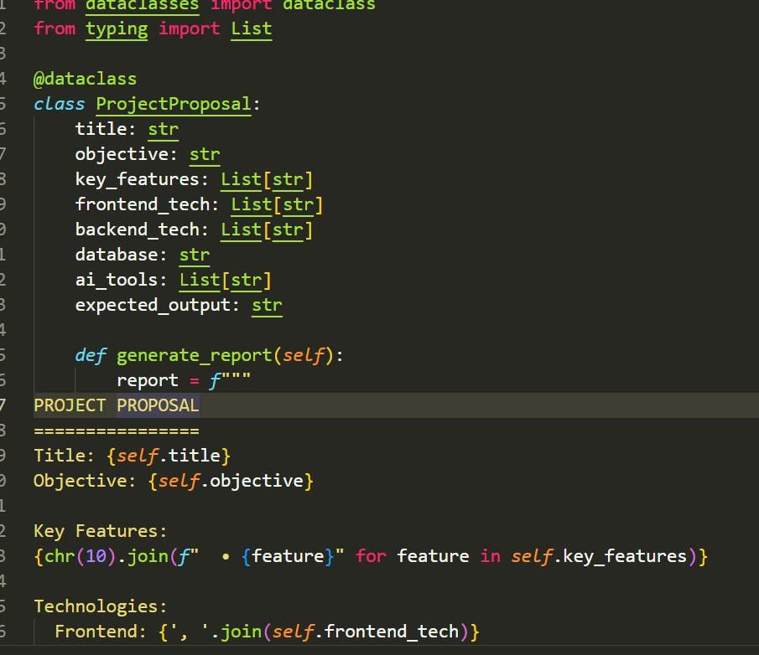
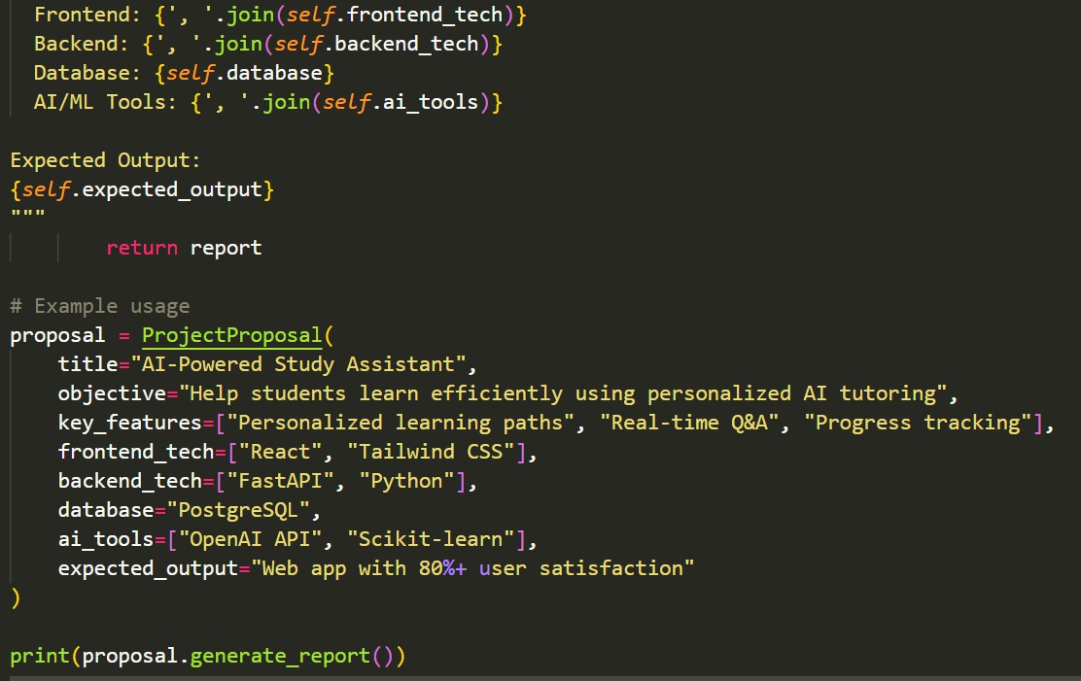

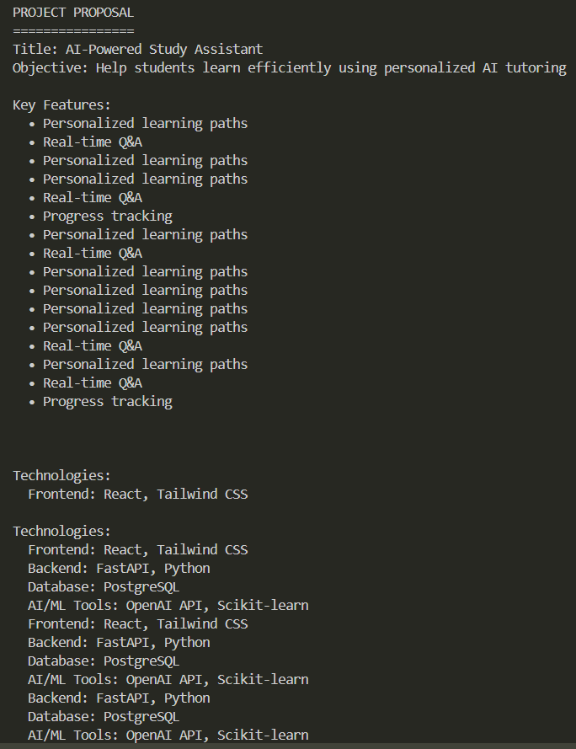
Explanation:

Task 2 – Application Design

- Use AI tools to assist in:
- Designing system architecture diagrams.
- Defining database schema (if needed).
- Creating wireframes/UI mockups for frontend design. Prompt used:
Design the system architecture for an AI-powered web application. Include a clear
architecture diagram (text-based), database schema with tables and attributes, and basic UI wireframe descriptions for each screen (home, dashboard, input page, AI assistant).
Keep the design simple, scalable, and suitable for student-level implementation.
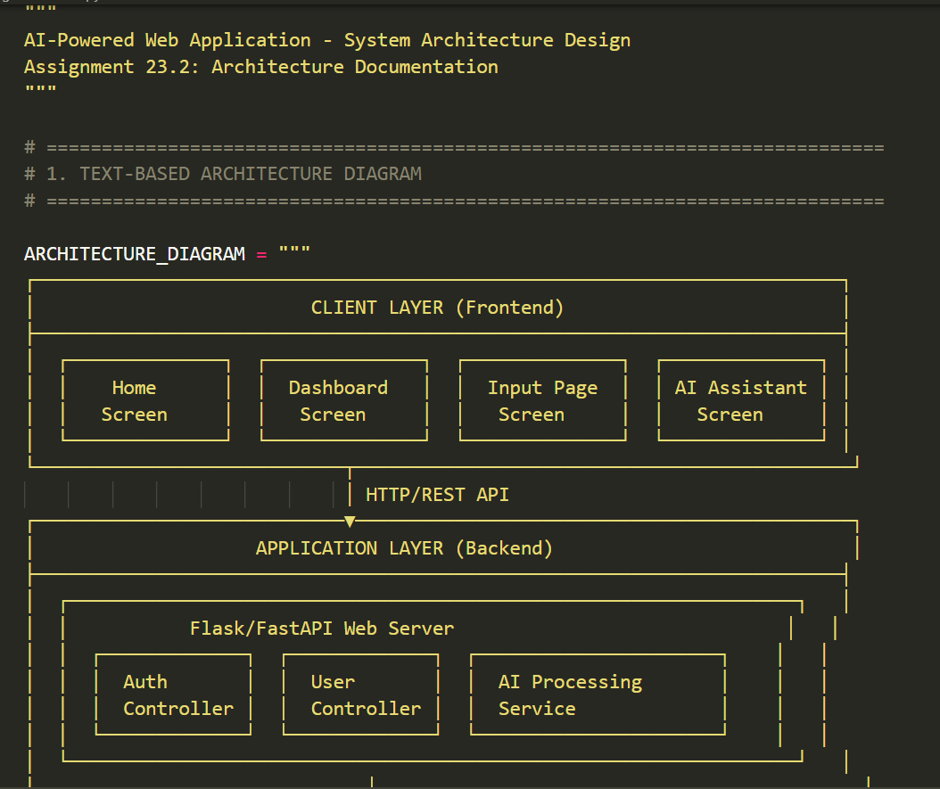

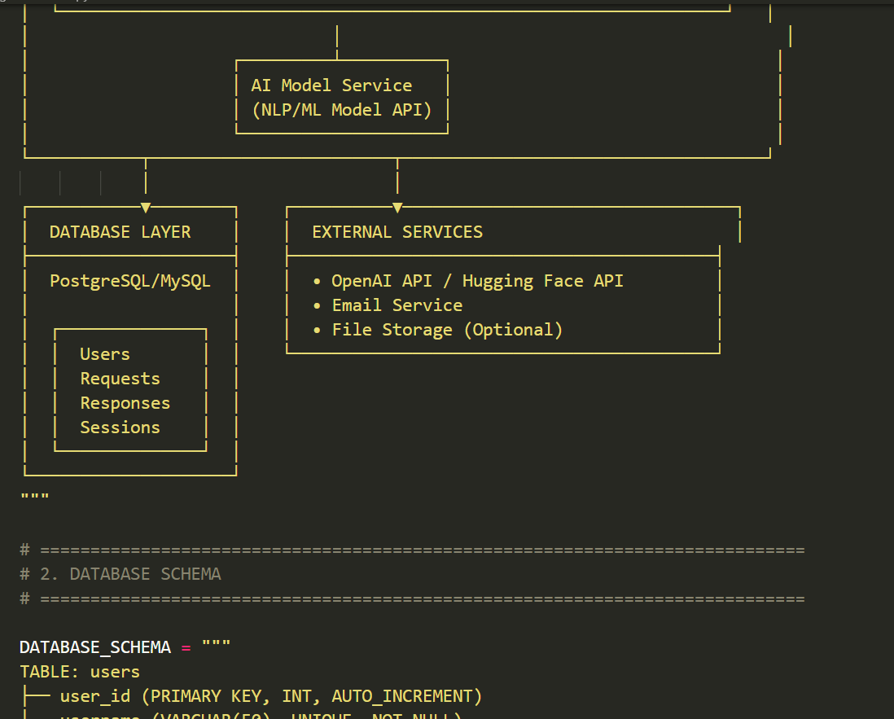

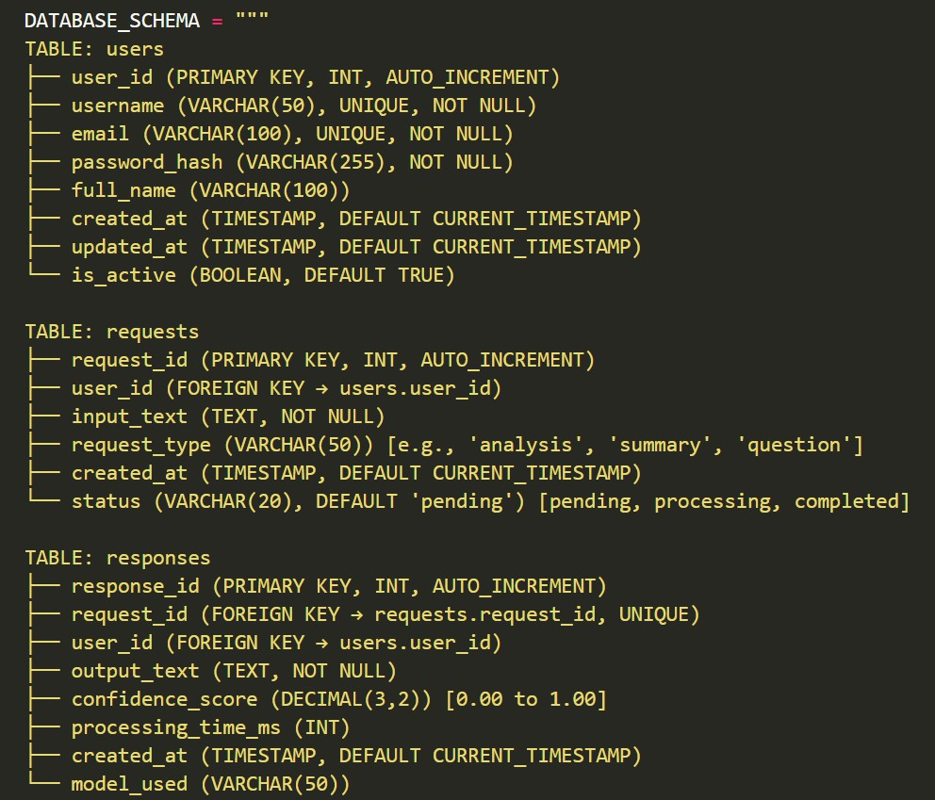

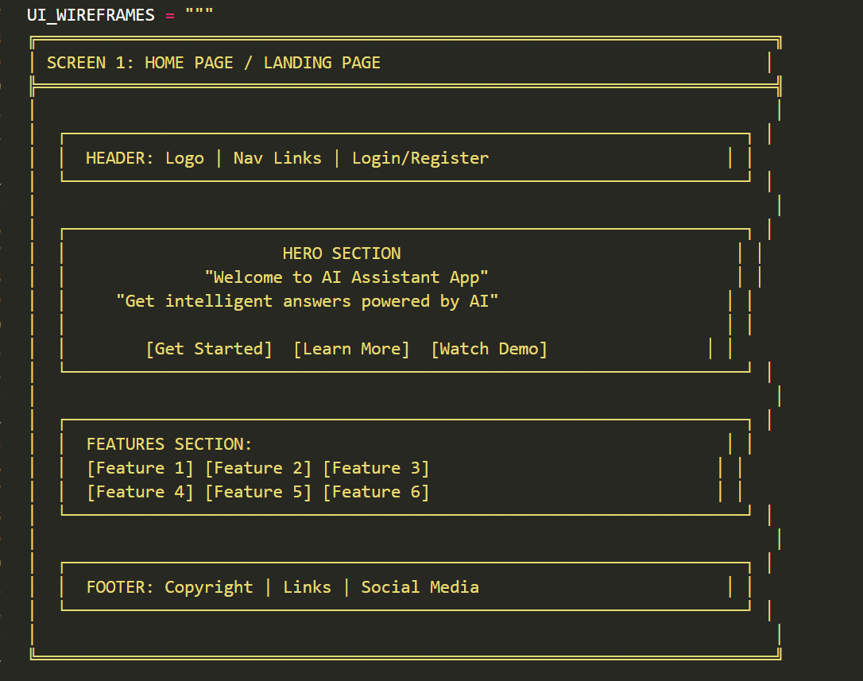

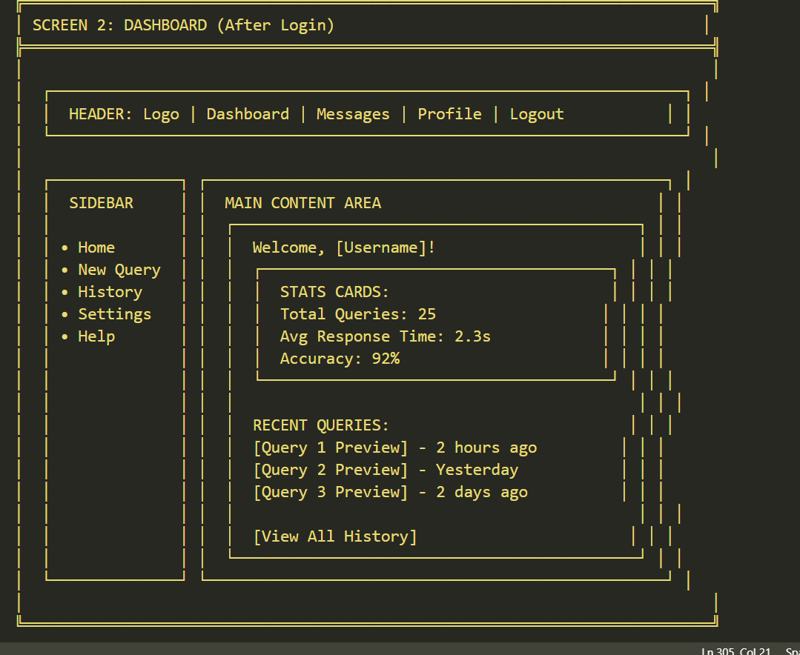

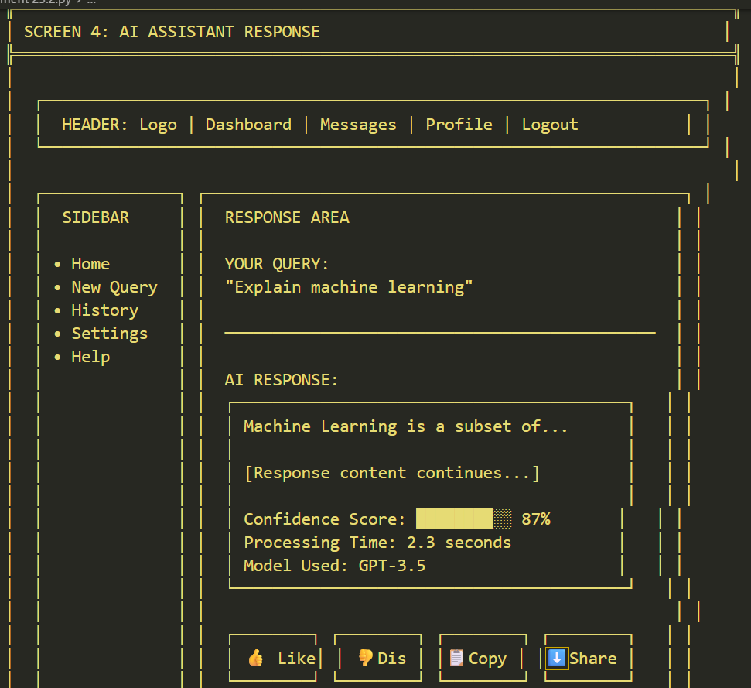

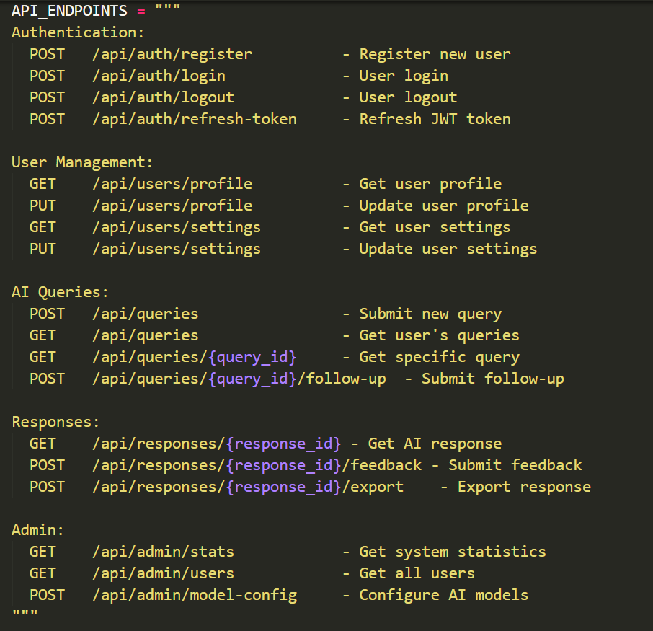

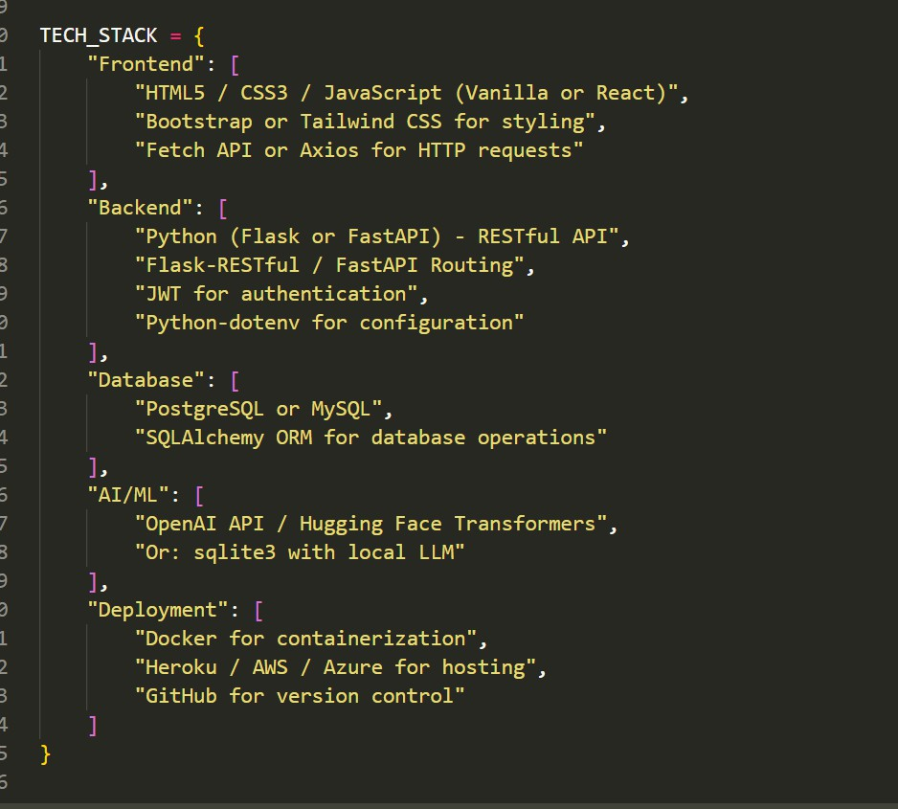
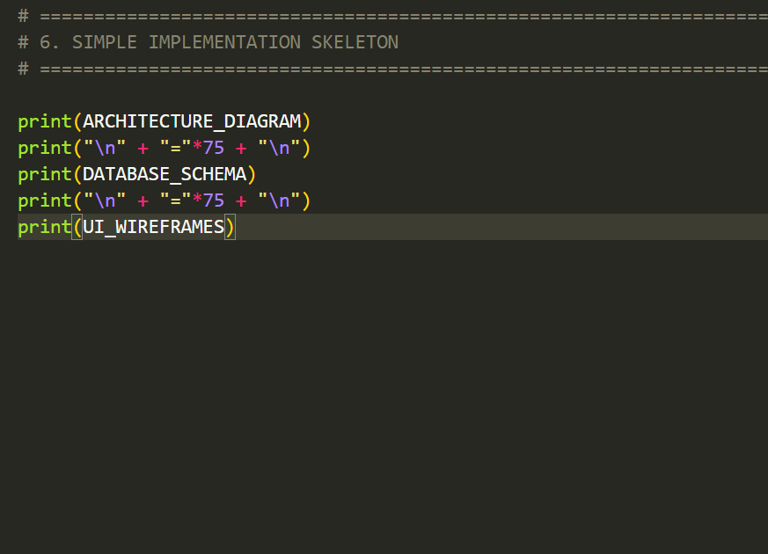

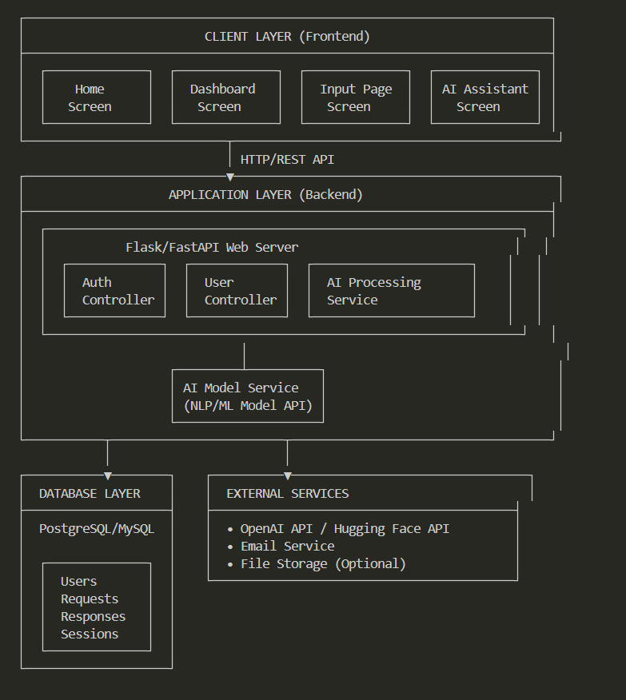

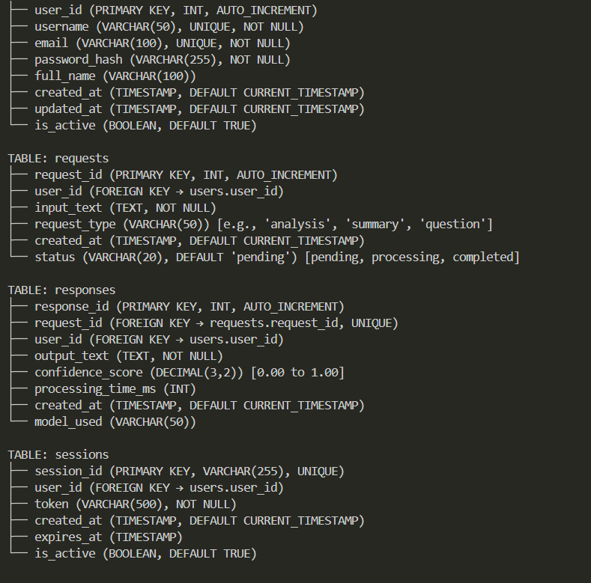
Explanation-
Task 3 – AI-Assisted Code Development
- Implement the application in phases:
- Frontend: Web/mobile UI with HTML/CSS/JS (or framework).
- Backend: RESTful APIs or server logic.
- Database: Schema design, SQL queries.
- Integration: API calls, authentication, error handling. Prompt Used:

Generate complete starter code for an AI-powered web application including frontend
(HTML, CSS, JavaScript), backend (Flask or Node.js API), and database integration. Include API routes, sample UI, and basic AI chatbot integration using an API. Ensure the code is modular, well-structured, and beginner-friendly.

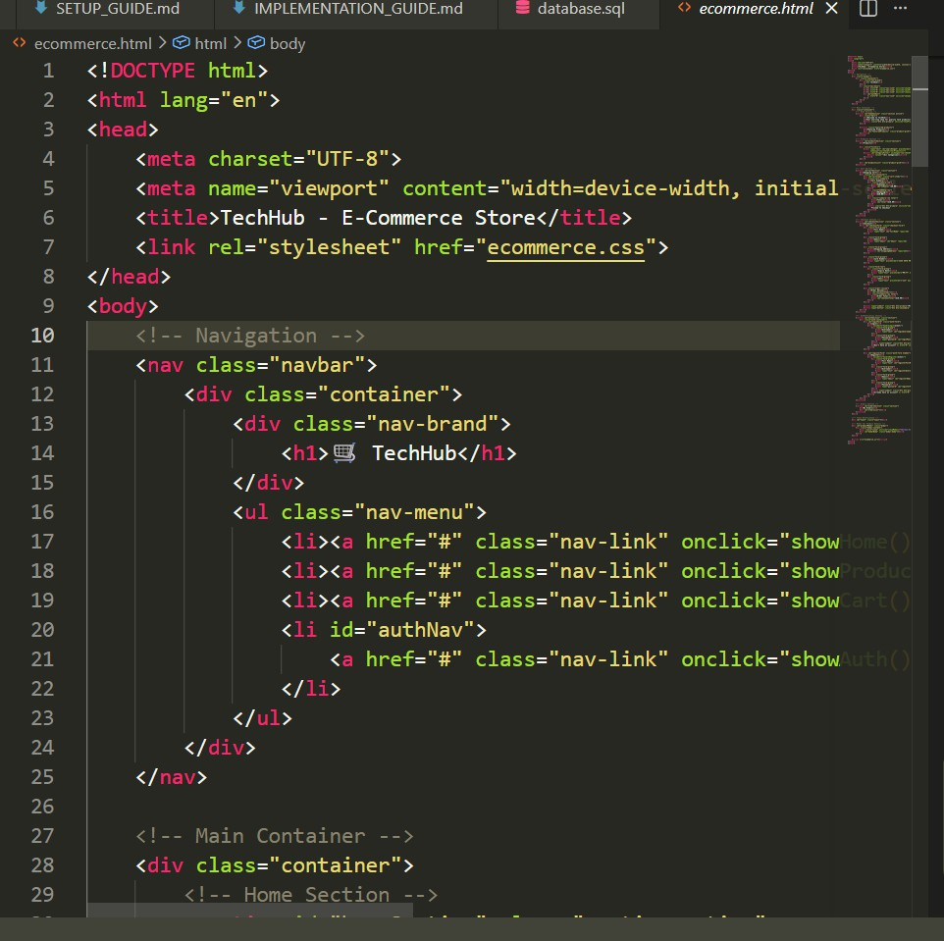

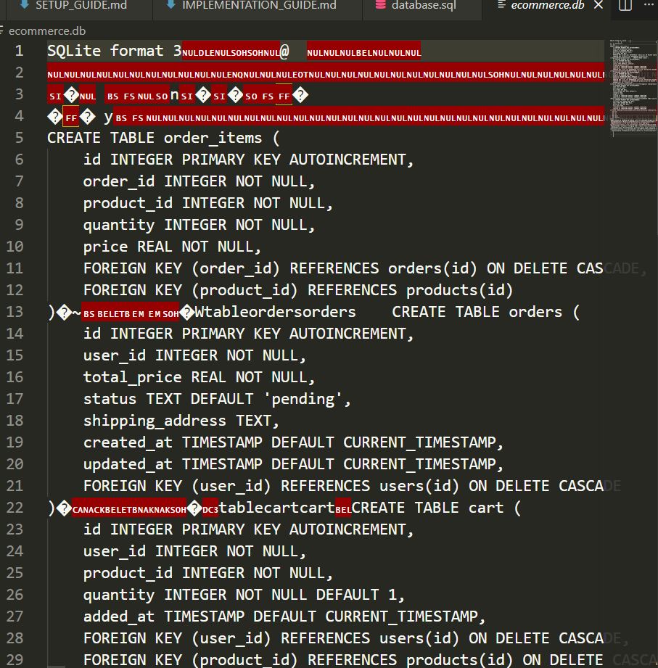

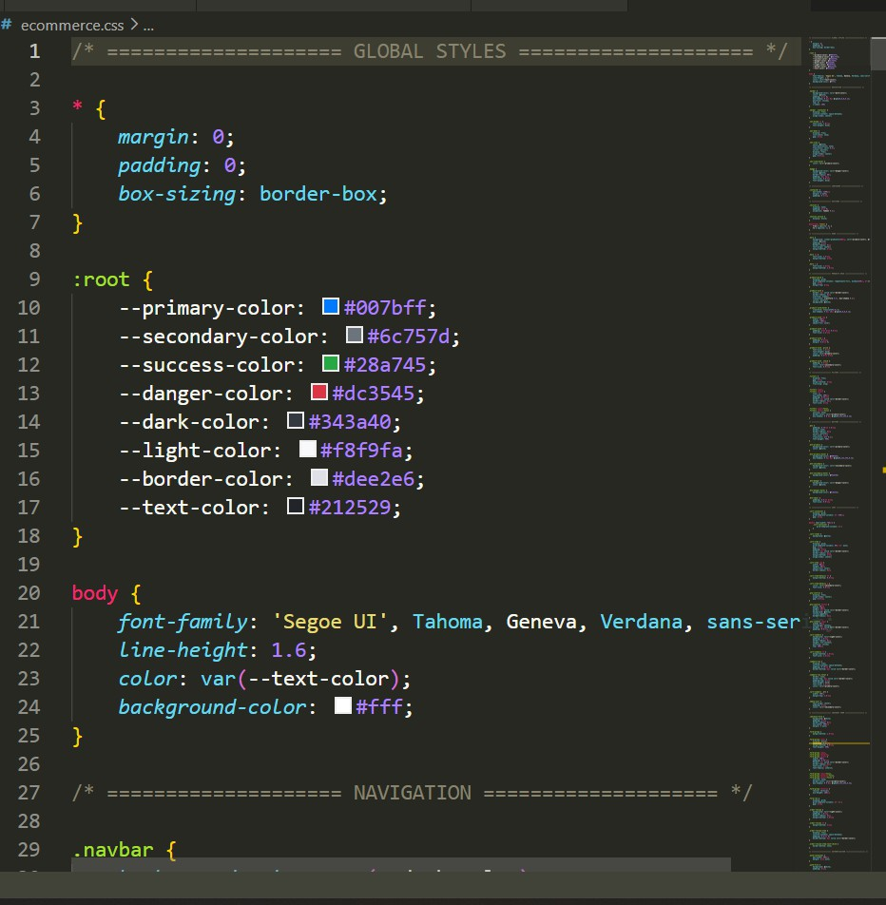

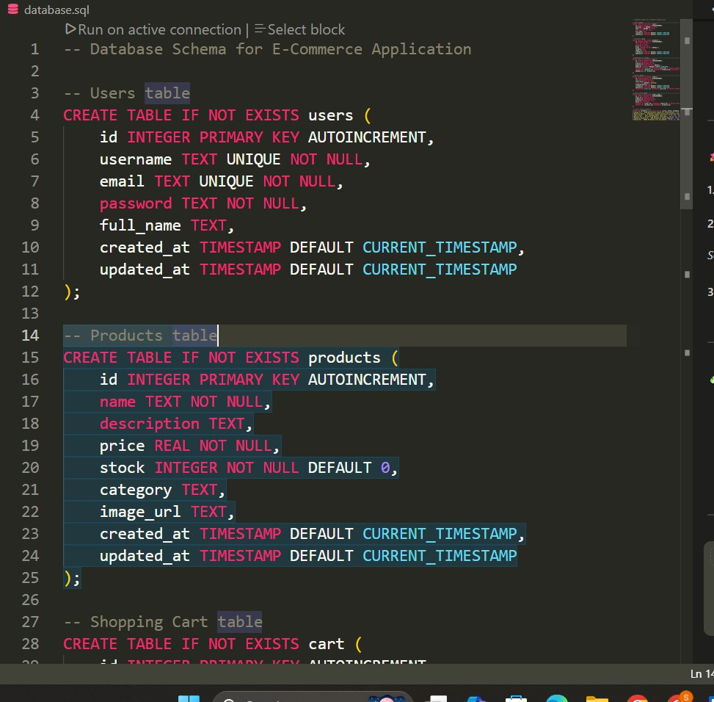


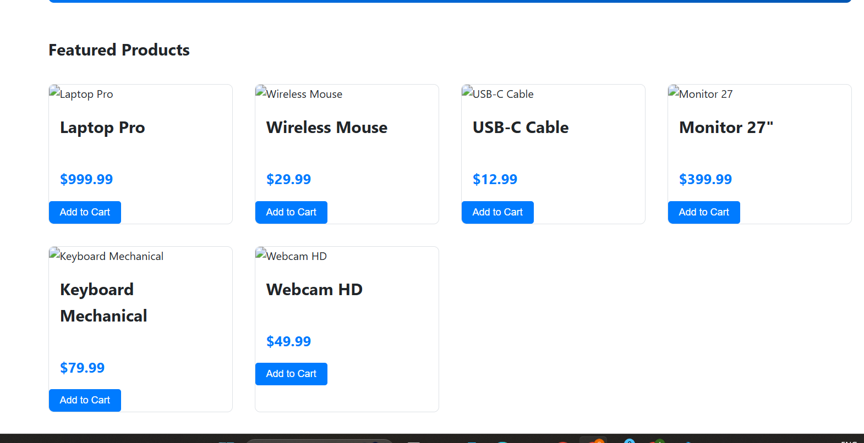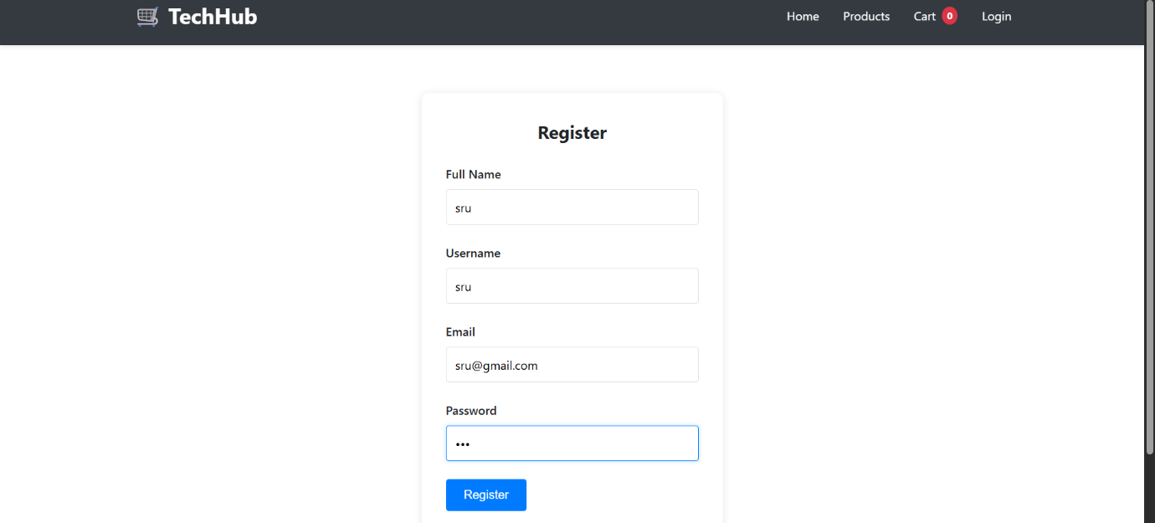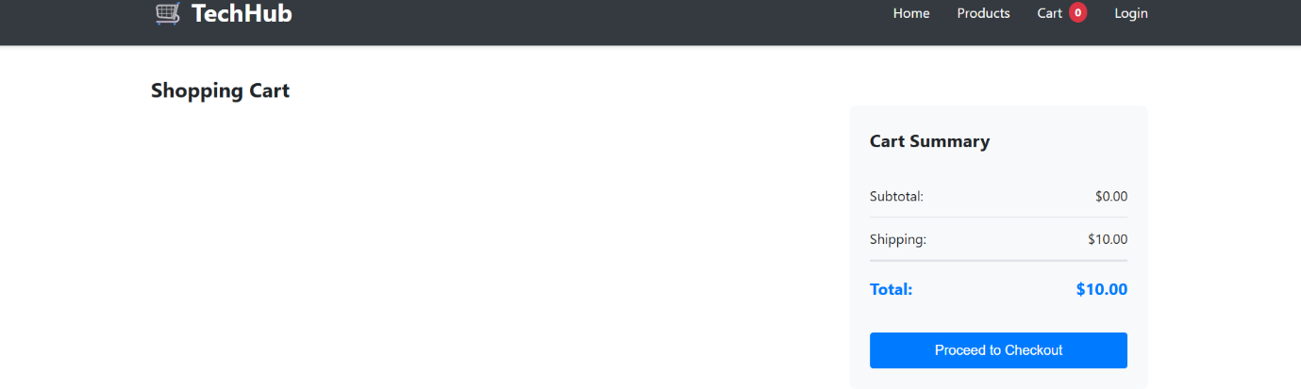

Task 4 – Documentation & Code Quality
- Generate automatic documentation and inline comments using AI.
- Ensure clear README.md for project setup and usage.
- Conduct AI-assisted code review to refine readability and maintainability.
Prompt used :
Create a complete README.md file for an AI-powered web application project. Include project description, features, technologies used, installation steps, usage instructions, and folder structure. Also add inline code comments and suggestions to improve code readability and maintainability.

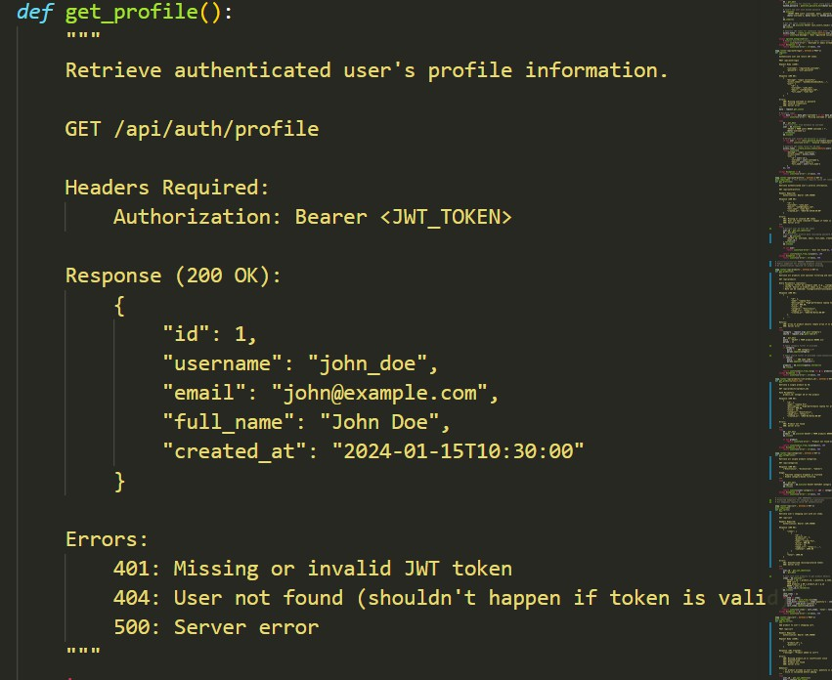

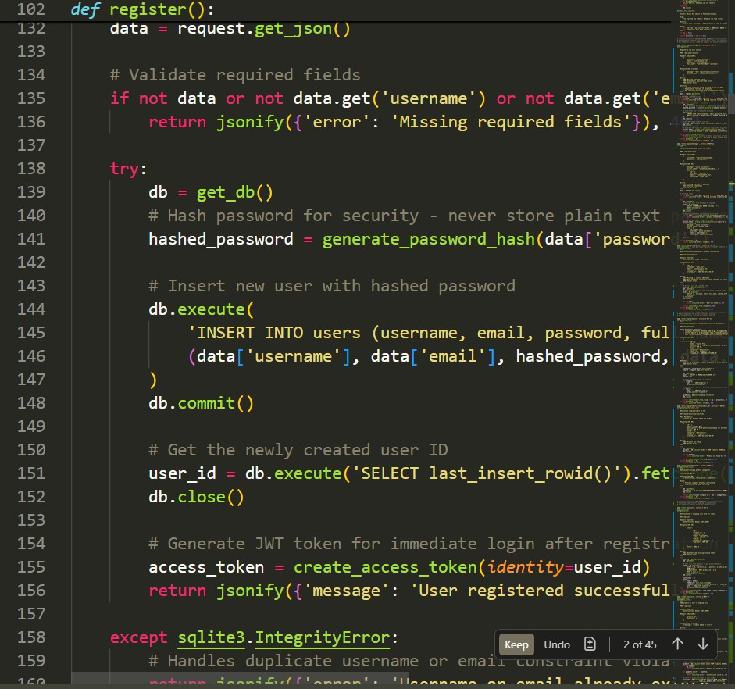

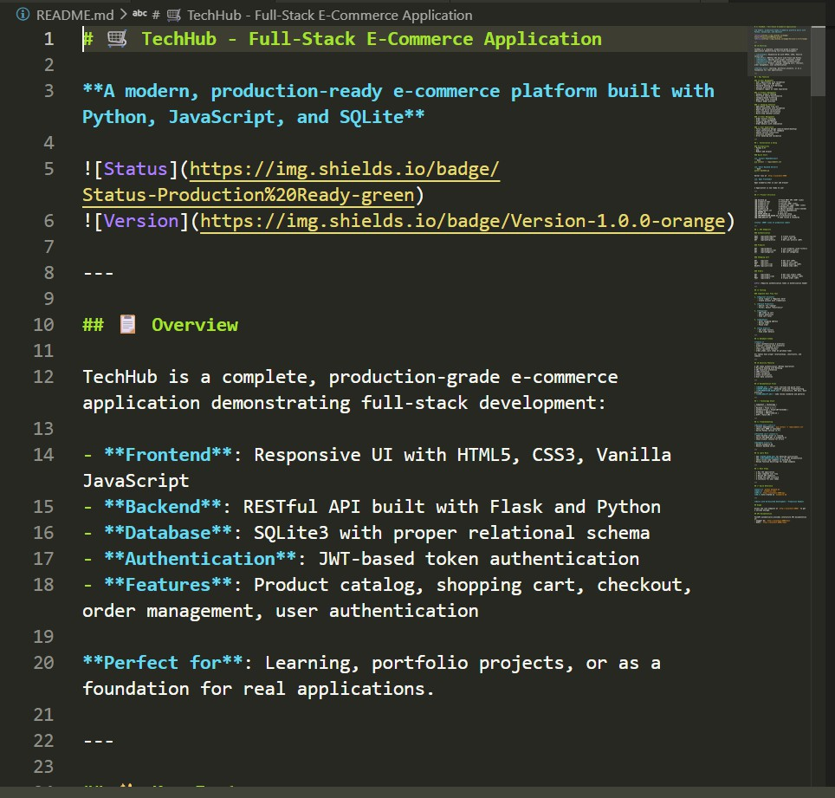

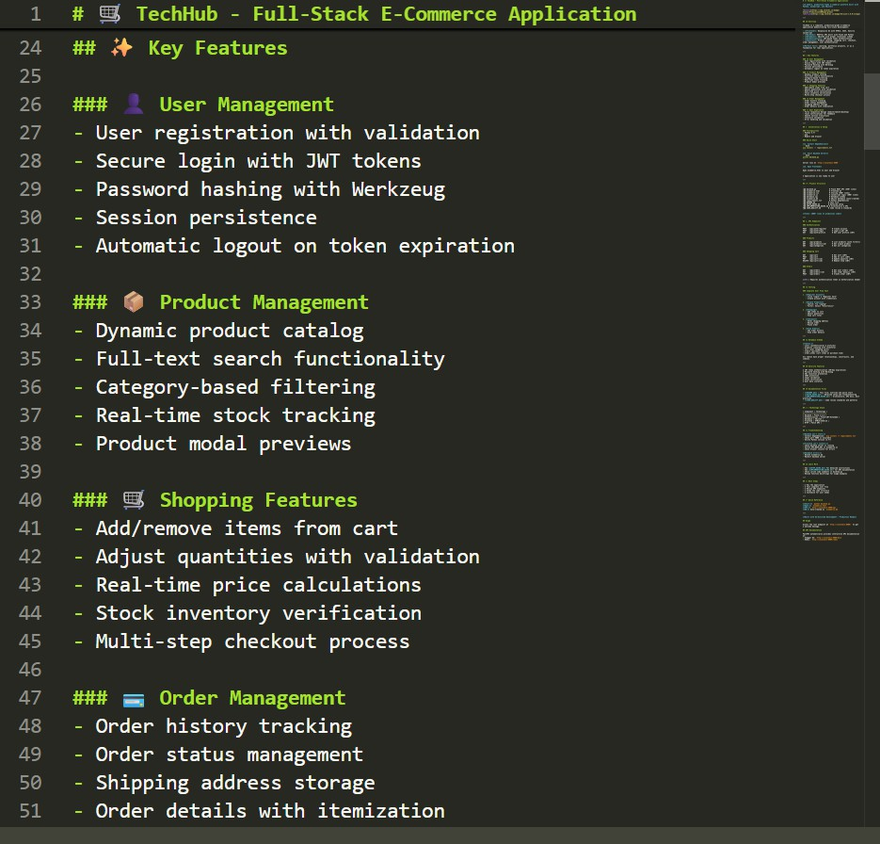

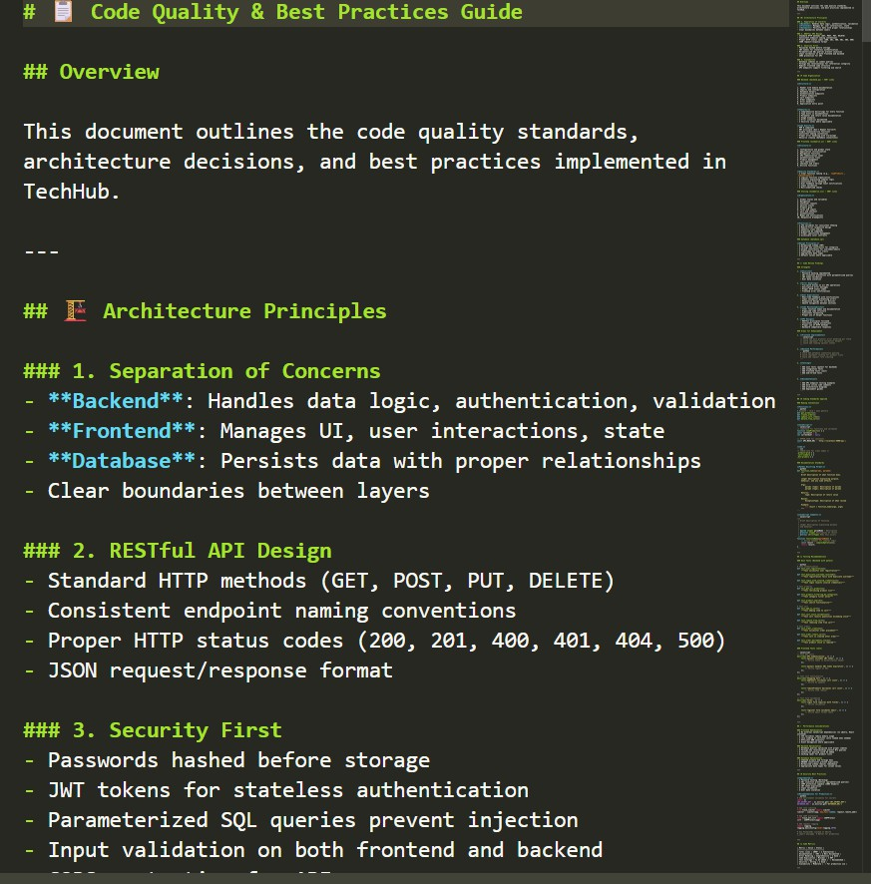

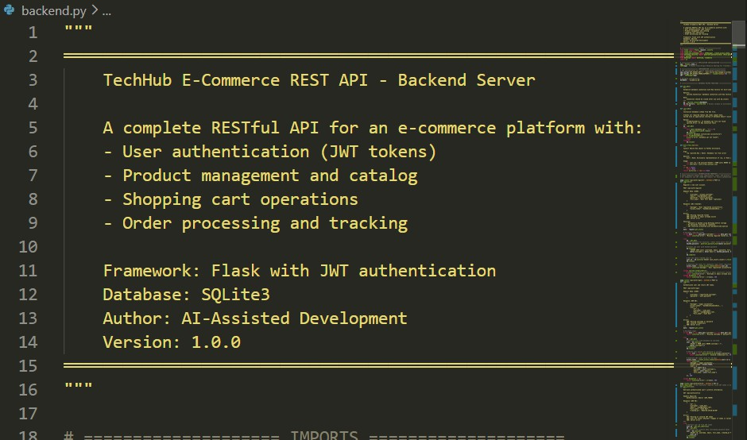

Task 5 – Testing & Debugging
- Use AI to:
- Generate unit tests.
- Identify vulnerabilities/security flaws.
- Suggest optimizations for performance.

Prompt used-
Generate unit tests and debugging strategies for an AI-powered web application. Include sample test cases for frontend and backend, identify potential bugs and security
vulnerabilities, and suggest performance optimizations. Keep it simple and suitable for student-level projects.

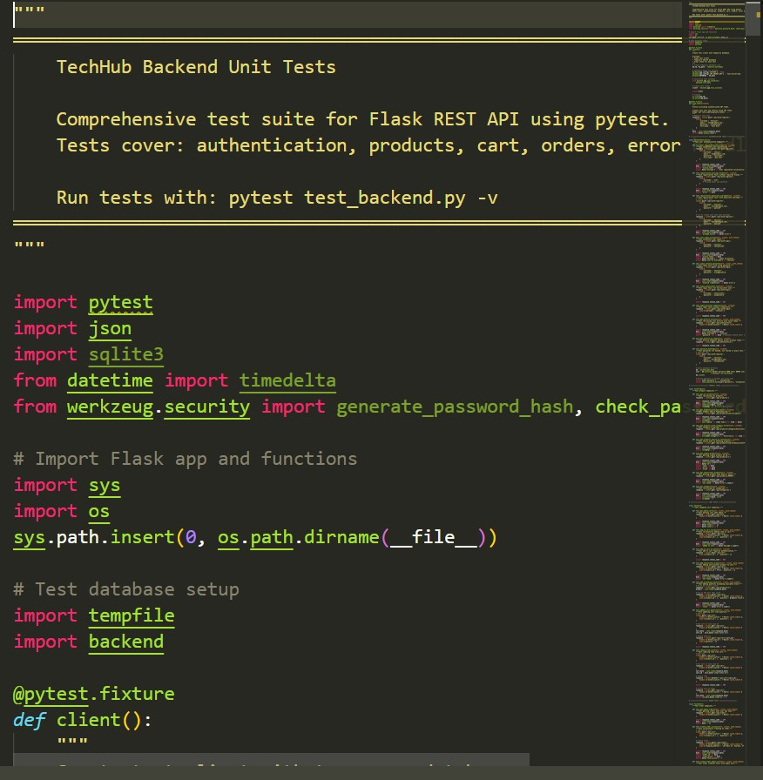

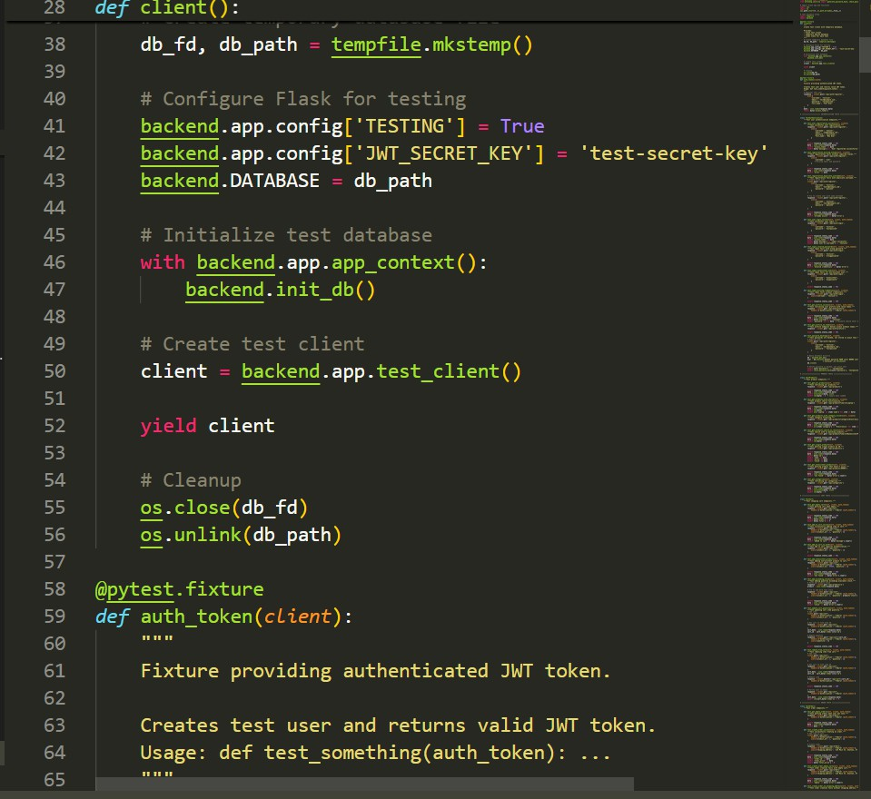

Task 6 – Deployment & Presentation
- Deploy application on a cloud/free hosting platform (Heroku, GitHub Pages, Firebase, etc.).
- Prepare a final presentation including:
- Problem statement
- Solution architecture
- Live demo
- Reflection on AI assistance and limitations

prompt used-
Provide a step-by-step guide to deploy an AI-powered web application using platforms like GitHub Pages, Firebase, or Heroku. Also generate a presentation outline including problem statement, solution, architecture, demo, and conclusion. Keep it concise and easy to
present in a classroom.
